# WORKSHEET FOR PICTURE DESCRIPTION

**Q. Look at the following pictures carefully. Write few lines about it by describing, comparing and contrasting both the pictures:**

# PICTURE 1 : An online Vegetable market



# PICTURE2: Local vegetable shop

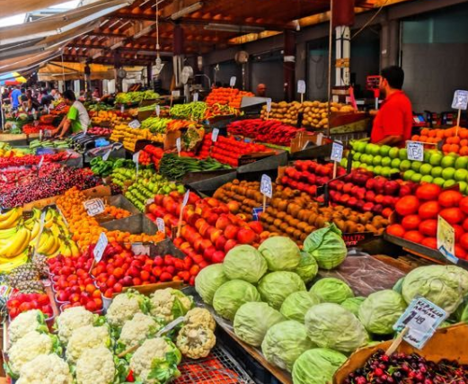

# PICTURE 3 : A Zoo

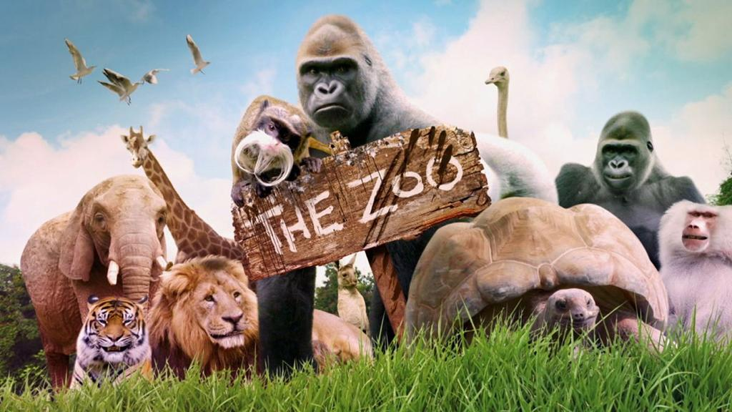____________________________________________________________________________________________________________________________________________________________________________________________________________________________________________________________________________________________________________________________________________________________________________________________________________________________________________________________________________________________________________________________________________________________________________________________________________________________________________________________________________________________________________________________________________________________________________________________________________________________________________________________________________________________________________________________________________________________________________________________________________________

# Picture: 4 Natural Habitat



